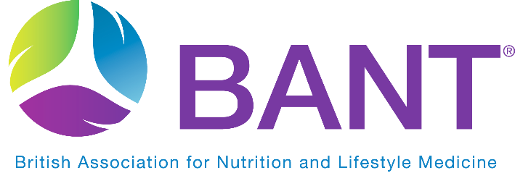
PRESS CONTACT: Claire Sambolino
communications@bant.org.uk

New food-first tactics are needed to tackle the modifiable factors involved in obesity and metabolic dysregulation
Figures show that a staggering 63% of the British population is now classified as overweight or obese (1). And being overweight is just the tip of the iceberg. Once you scratch below the surface the number of related metabolic health conditions grows exponentially with 2 million adults at risk of developing Type 2 diabetes (2), 6 out of 10 adults living with high cholesterol (3) and 1 in 4 adults with high blood pressure (4). This adds up to a nation with increasingly poor health and at greater risk of developing chronic illness. Furthermore, it costs the NHS billions each year. The role of diet and lifestyle is increasingly important in this battle against diet-induced chronic disease which is the motivation for the BANT Food for your Health campaign launched 22nd February 2021.
Whilst alarming, these statistics point to something else. The fact that as a nation, we no longer know how to eat to support our health. We need to reclaim food as the first-line defence in prevention and personal health management.
What all the above metabolic symptoms have in common is that they can be directly modified by diet and lifestyle choices. Many are themselves diet-induced and a result of long-term poor dietary choices. Within nutritional therapy it is not uncommon to see clients in various stages of blood sugar and insulin dysregulation, high LDL cholesterol and low HDL cholesterol, fatty liver disease, and weight management concerns. Applied personalised nutrition, based on a food-first philosophy is effective at supporting and in many cases ameliorating, symptoms. BANT is calling for greater recognition of the role personalised nutrition can play in supporting the health of individuals, and ultimately the nation.
The new Food for your Health campaign has been launched to encourage people to look at their diet with new eyes and adopt a food-first approach to prevent diet-induced chronic illness. The importance of good nutrition, healthy food choices, and supportive lifestyle habits such as regular physical activity, sleep and stress management all combine to give individuals greater autonomy over their health outcomes. Whilst Registered Nutritional Therapists work mostly in a one-to-one context, the campaign opens the doors to the wider public with a range of informative free resources available to download from the new campaign website https://bant.org.uk/food-for-your-health/.
- Ends -
(1) https://www.healthexpress.co.uk/obesity/uk-statistics
(2) https://www.england.nhs.uk/2020/02/record-high-two-million-people-at-risk-of-type-2-diabetes/
(3) https://publichealthmatters.blog.gov.uk/2015/10/12/high-cholesterol-beating-the-build-up-during-cholesterol-month/
(4) https://www.gov.uk/government/news/new-figures-show-high-blood-pressure-costs-nhs-billions-each-year

FOR FURTHER INFORMATION PLEASE CONTACT: Communications@bant.org.uk

NOTES TO EDITORS:
The British Association for Nutrition and Lifestyle Medicine (BANT) acts as a professional body for Registered Nutritional Therapy Practitioners in one-to-one clinical practice and as a self-regulator for BANT Registered Nutritionists®. BANT oversees the activities, training and Continuing Professional Development (CPD) of its practitioners and has a governing council, who may be non-members but whose professional experience lies in the medical, scientific or educational area of nutritional science.

BANT experts developed a set of Wellbeing Guidelines, based on the latest science and research in the field of nutrition for optimal health. The BANT Wellbeing Guidelines were specifically designed to provide clear, easy to understand general information for healthy diet and lifestyle when personalised advice is not available.

· THE WELLNESS SOLUTION
· FIGHT THE FAT / BEAT THE BLOAT (WEIGHT LOSS)

BANT “Food for your Health” Campaign launched in February 2021 further communicates the food first ethos, embracing food and diet as the first line strategy in support of health and in prevention of diet-induced illness.

Registered Nutritional Therapists are regulated by the Complementary and Natural Healthcare Council (CNHC) that holds an Accredited Voluntary Register (AVR) for the Professional Standards Authority for Health and Social Care (PSA). A report by the Royal Society for Public Health and the Professional Standards Agency made a key recommendation that AVR practitioners have the authority to make direct NHS referrals, in appropriate cases, to ease the administrative burden on GP surgeries. BANT Nutrition Practitioners are the key workforce asset to harness 21st century lifestyle medicine to tackle the rising tide of stress-related fatigue, obesity, Type 2 Diabetes, dementia and other chronic diseases.

To find a BANT Nutrition Practitioner, please click here

